2007年全国中学生英语能力竞赛（NEPCS）初一年级组试题
（全国中学生英语能力竞赛组委会办公室 提供）
（总分：150分 答题时间：120分钟）
听力部分（共四大题，计30分） （略）
笔试部分（共七大题，计120分）
I. 选择填空（Multiple-choice）（共20小题；每小题1分，计20分）
从A、B、C、D四个选项中，选出可以填入空白处的最佳选项。(Beneath each of the following sentences there are four choices marked A, B, C and D. Choose the answer that best completes the sentence.)
31. 国际上用_________表示不明飞行物。
A. SUS B. VOA C. SOS D. UFO
32. 英语字母是按照一定笔顺书写的，下列小写字母中_________和_________均是两笔完成的。
A. k; w B. p; i C. t; z D. f; e
33. 朗读英语句子时，_________这些实词多_________。
A. 形容词、介词、冠词；重读 B. 连词、动词、代词；不重读
C. 名词、动词、代词；重读 D. 冠词、介词、副词；不重读
34. 罗马数字XI，用英语数字可表示为_________。
A. eleven B. eighteen C. nineteen D. twenty-one
35. 下列各句标点及书写均正确的是_________。
A. There is a computer、some paper on the table．
B.“Shrek II”is very popular among children.
C. Jim says, “whose book is this”?
D. I can't drive a car or ride a bike; but Jim can.
36. After school we usually play _________ soccer for half _________ hour on _________ playground.
A. /; an; the B. the; a; the C. /; a; a D. the; an; a
37. Nancy can't find _________ eraser. Can you lend _________ to her?
A. her; her B. her; yours C. my; yours D. /; yours
38. Lily and Lucy are twins from _________. They like _________ films very much.
A. Americans; America B. America; Americans
C. American; Americas D. America; American
39. The book on the table isn't very good. It's very _________.
A. interesting B. boring C. exciting D. wonderful
40. Nancy writes books _________ children _________ 14—15.
A. to; for B. for; of C. with; of D. about; for
41. There are _________ months in the year. December is the _________ one.
A. twelve; twelve B. twelfth; twelve
C. twelve; twelfth D. twelfth; twelfth
42. —Must I go to clean the classroom now? —No, you _________.
A. can't B. mustn't
C. don't have to D. may not
43. I like the story very much, _________ Betty isn't interested in it.
A. and B. so C. or D. but
44. She has a pen in one of her hands, but what's that in _________ hand?
A. another B. the other C. other D. the others
45. —_________ is your new teacher? —The one in the white shirt.
A. Whose B. What C. Which D. Whom
46. —Aren't they working?
—_________, but they aren't working well.
—Sure, we need a hand.
A. No, they aren't B. Yes, they are
C. Sorry, I don't know D. Sure, they do
47. —Let's go to the movies tomorrow!
—Sorry, I have to do some cleaning tomorrow.
—How about tonight?
—_________.
A. I'm glad you like it B. Yes, she's OK
C. That sounds good D. I think so
48. —Can I come and see it this afternoon? —_________
A. Sure, come over about two.
B. Not at all.
C. I'm sorry, I can't go today.
D. You're welcome.
49. —What's the relationship between Eric and me?
—_________ Do you understand?
—I think I understand.
A. They are twins. B. You are cousins.
C. Is he your brother? D. It's Tom Wilson.
50. —What club does Jack want to join?
—The art club.
—_________?
—I think so.
A. Can he paint well
B. Does he paint well or bad
C. What can he do in the club
D. Do you like the art club, either
II. 阅读理解(Reading comprehension) （共20小题；选择题5小题，每小题1分；非选择题15小题，每小题2分，计35分）
A) 选择题：阅读下面的短文，根据短文内容从每题所给的四个选项（A、B、C和D）中，选出能回答所提问题或完成所给句子的最佳选项。(Read the following passage which is followed by five questions. For each of them there are four choices marked A, B, C and D. Choose the one that fits best according to the passage.)
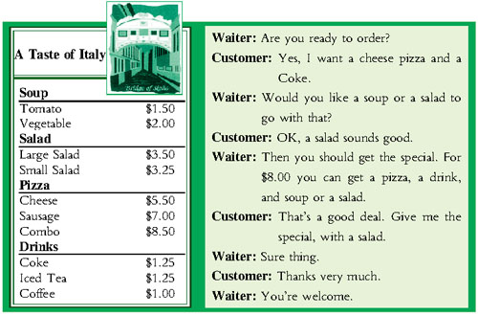
51. Which country's food does this restaurant sell?
A. England. B. France. C. America. D. Italy.
52. How many kinds of pizza are there?
A. One. B. Two. C. Three. D. Four.
53. What doesn't the customer want?
A. The special. B. A soup.
C. Something to drink. D. A pizza.
54. How much does the customer pay for the food?
A. $11.50. B. $10.25. C. $10.00. D. $8.00
55. Which of the following is TRUE?
A. The waiter helps the customer save money.
B. All the food the restaurant sell is English food.
C. A bowl of tomato soup is the same price as a Coke.
D. The special comes with a soup, a salad, or two pizza.
B) 非选择题：阅读下列短文，然后按短文后的要求完成所给出的题目。(Read the following three passages. Each passage is followed by several questions. Respond to the questions according to the passage.)
A
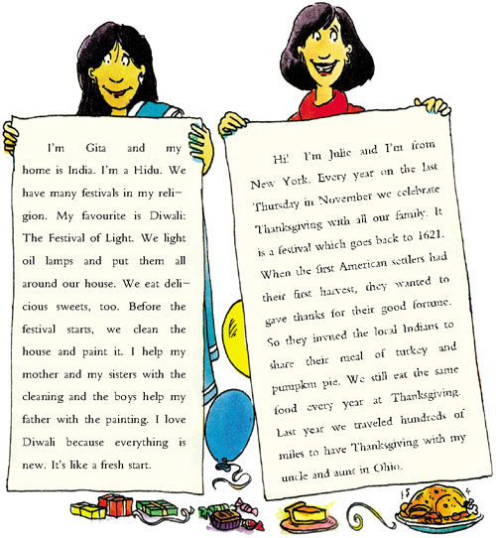
Questions 56-60: 根据短文内容，完成下面的表格。(Complete the form according to the passage.)
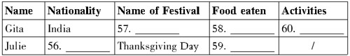
B
These notices come from Kate's school noticeboard.
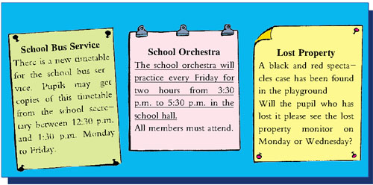
Questions 61-64: 根据短文内容完成句子。(Complete the following sentences according to the passage.)
61. There are _________ notices on the noticeboard.
62. You may get the new timetable from _________ to Friday.
63. The pupils must see _________ to get copies of the new bus timetable.
64. The pupils who lost things can see the lost property monitor _________ days a week.
Question 65: 将文中划线的句子翻译成汉语。(Translate the underlined sentence into Chinese.)
C
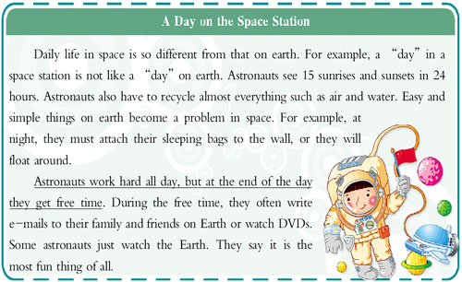
Questions 66-69: 根据短文内容完成句子。(Complete the following sentences according to the passage.)
66. If you are in space, you can see ________ sunrises and sunsets in a whole day.
67. Some astronauts think ________ is the most fun thing to do during their free time.
68. Astronauts have to attach their sleeping bag to the wall, or they will ________.
69. Astronauts often ________ during their free time.
Question 70: 将文中划线的句子翻译成汉语。(Translate the underlined sentence into Chinese.)
III. 完形填空(Cloze) （共20小题；每小题1分，计20分）
A) 阅读下面的短文，根据其内容从所给的12个单词或短语中选择10个，并以其适当的形式填空。(Read the passage below, and fill in the blanks with the correct form of 10 words or phrases of the 12 given.)
anything, interest, own, something, some, like,
all, her, have, the others, library, so
Lucy is a well-known librarian in her hometown. She loves the (71)________. It's like her second home. There are so many (72)________ books there. Each one has its (73)________ secrets. Each one has (74)________ to teach and share. Some (75)________ beautiful pictures.(76)________ have interesting stories. To Lucy, books are (77)________ her good friends. At the library, Lucy has friends (78)________ around her.
Lucy is always ready to help people, (79)________ the staff at the library all like her. They help (80)________ choose books for the readers.
B) 阅读下面的短文，根据其内容用括号内所给动词的适当形式填空。(Read the passage below, and fill in the blanks with proper forms of the words given in the brackets.)
The Spring Festival (81)________(be) coming. Tina (82)________(love) this time of the year. She can (83)________(get) up late and (84)________(play) all day. She (85)________(not, do) any homework. Everybody in her family (86)________(be) happy at this time because they all (87)________(have) a long holiday. Her mother usually (88)________(teach) her to cook something delicious. Her father (89)________(buy) some gifts for her! He always (90)________(give) her a surprise. For Tina, the happiest thing is to receive a gift from her father.
IV. 句式转换（Sentence pattern transformation）（共5小题；每小题1分，计5分）
根据上句完成下句，使两句表达的意思基本相同，每空一词。(Complete the following sentences so that each pair of sentences has the same or a similar meaning. Use only one word for each blank.)
91. Emma is like her aunt.
Emma and aunt ________ ________ ________.
92. How old is Lena?
________ Lena's ________?
93. Jack is Lily's good friend.
Jack and ________ ________ good ________.
94. They usually get to school at 8 o'clock.
They usually ________ ________ school at 8 o'clock.
95. Can I help you?
________ can I ________ ________ you?
V. 翻译(Translation) （共5小题；每小题2分，计10分）
根据所给提示词，将下列汉语句子翻译成英语。(Translate the following sentences into English, using the words given in the brackets.)
96. 他读书多，所以懂得也多。 (a lot)
97. 我认为数学没趣。(interesting)
98. 看电影是他的爱好之一。(one of)
99. 到我们睡觉的时间了。(It's time...)
100. 欢迎到我们学校来。(welcome)
VI. 智力测试(IQ) （共5小题；每小题1分，计5分）
按要求完成下列各题。(Answer the following questions.)
101. Sam: How about trying the new French restaurant tonight?
Tom: I heard it's very expensive.
Sam: Why don't we go Dutch?
Tom: Good idea!
Read the dialogue, can you guess the meaning of “go Dutch”? You may answer it in Chinese.
102. Sue is 5 years older than her younger brother Paul. Paul is 6 years older than Jim, the youngest in the family. If the total of the children's ages is 32, how old is the eldest child?
103. What number should replace the question mark in the last circle?
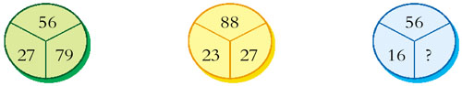
104. Which letter should appear in the final medal? 
105. Look at the shapes and codes given.Work out the code which matches the shape given at the end of the line.
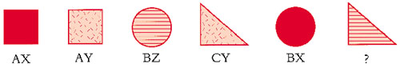
VII. 写作(Writing) （共2小题；A题满分10分，B题满分15分，计25分。）
A
Lucy想加入音乐俱乐部，请你写一段接待员与Lucy之间的对话。
要求：1. 将卡片所给信息全部体现在对话中,并发挥想象适当拓展对话；
2. 条理清楚，意思连贯，语句通顺，标点正确，书写规范、清晰；
3. 不得少于50词。
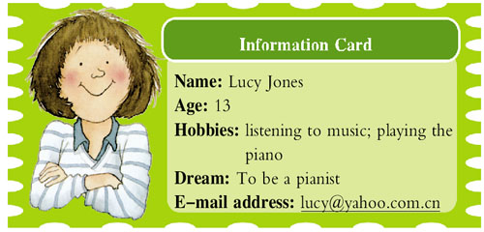
B
Wang Fei has a pen pal named Rose. She's from the USA. They often share happiness and sadness with each other. Here's a letter from Rose.
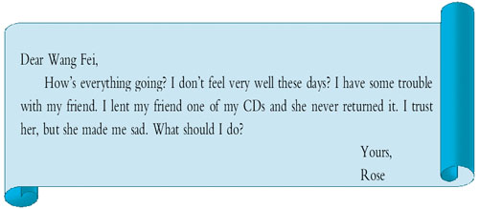
假设你是Wang Fei，请根据Rose的来信，写一封回信，帮助Rose解决问题。
要求:1. 叙述有条理，符合逻辑；2. 用词得当，语法正确；3. 书写清晰、规范；4. 不得少于60词。

声明：本资料由 考试吧（Exam8.com） 收集整理，转载请注明出自 http://www.exam8.com
服务：面向较高学历人群，提供计算机类，外语类，学历类，资格类，会计类，工程类，医学类等七大类考试的全套考试信息服务及考前培训.

