试卷类型：A
泰安市二〇〇九年高中段学校招生考试
英 语 试 题
本试卷分第I卷（选择题）和第II卷（非选择题）两部分。第I卷1 至8 页。第II卷9至12页。共120分。考试时间120分钟。

第I卷（三部分，共80分）
注意事项：
1. 答第I卷前, 考生务必将自己的姓名、准考证号、考试科目、试卷类型涂写在答题卡上。
2. 每小题选出答案后, 用铅笔把答题卡上对应题目的答案标号涂黑。如需改动, 用橡皮擦干净后, 再选涂其他答案标号。不能答在试卷上。

第一部分 听 力 (共25小题，每小题1分；满分25分)
(一) 听句子，选择适当的应答语。每个句子读两遍。
1. A. I’m Chinese. B. I’m not well. C. I’m a foreigner.
2. A. She walks much. B. She does every day. C. She walks to school.
3. A. What a pity! B. Help yourself. C. Watch out.
4. A. Not at all. B. Thank you. C. No, not so good.
5. A. Let’s go. B. I’m ready. C. Yes, I have.
(二) 听对话，选择相应的图画。每段对话读两遍。
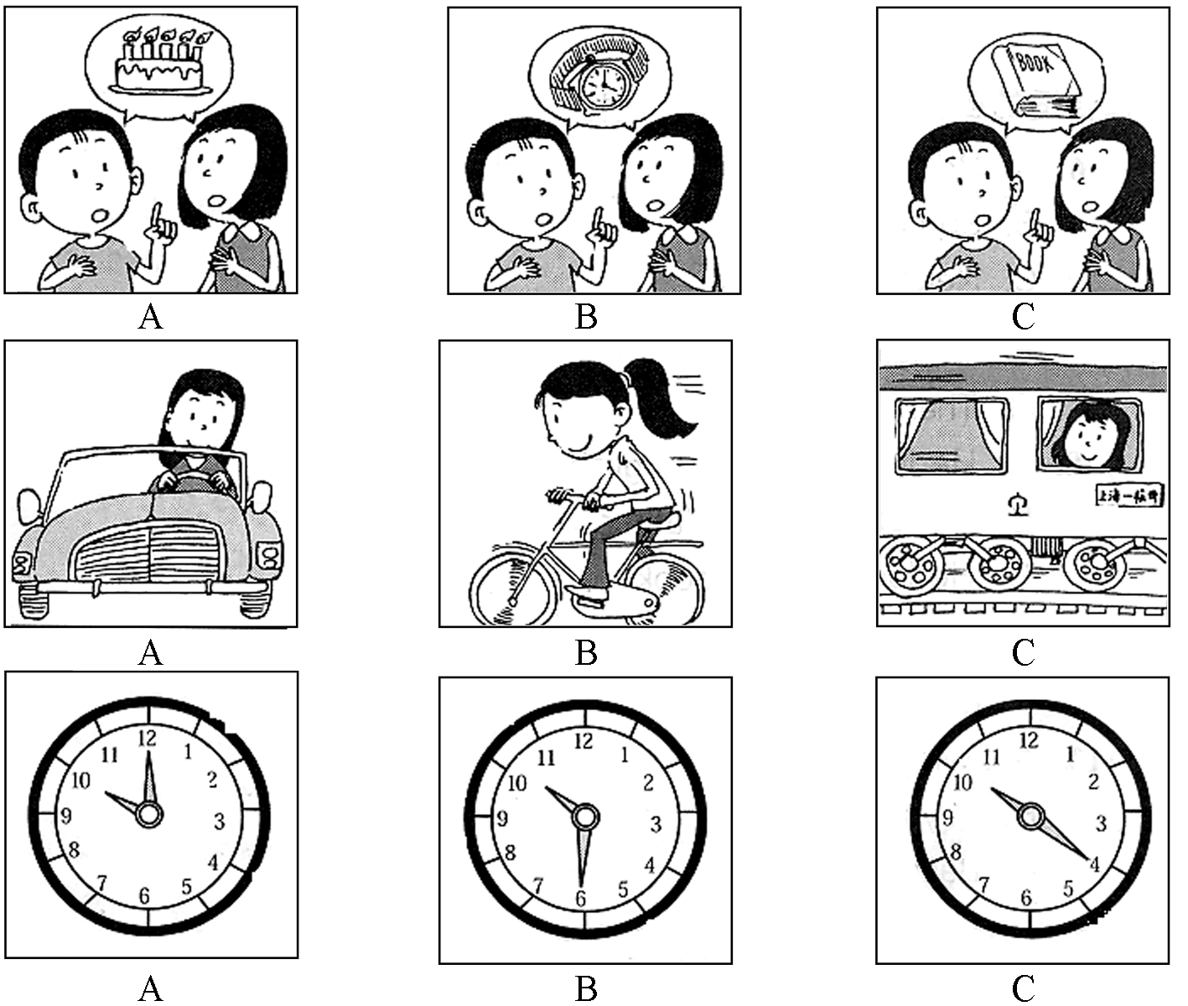
6.

7.

8.

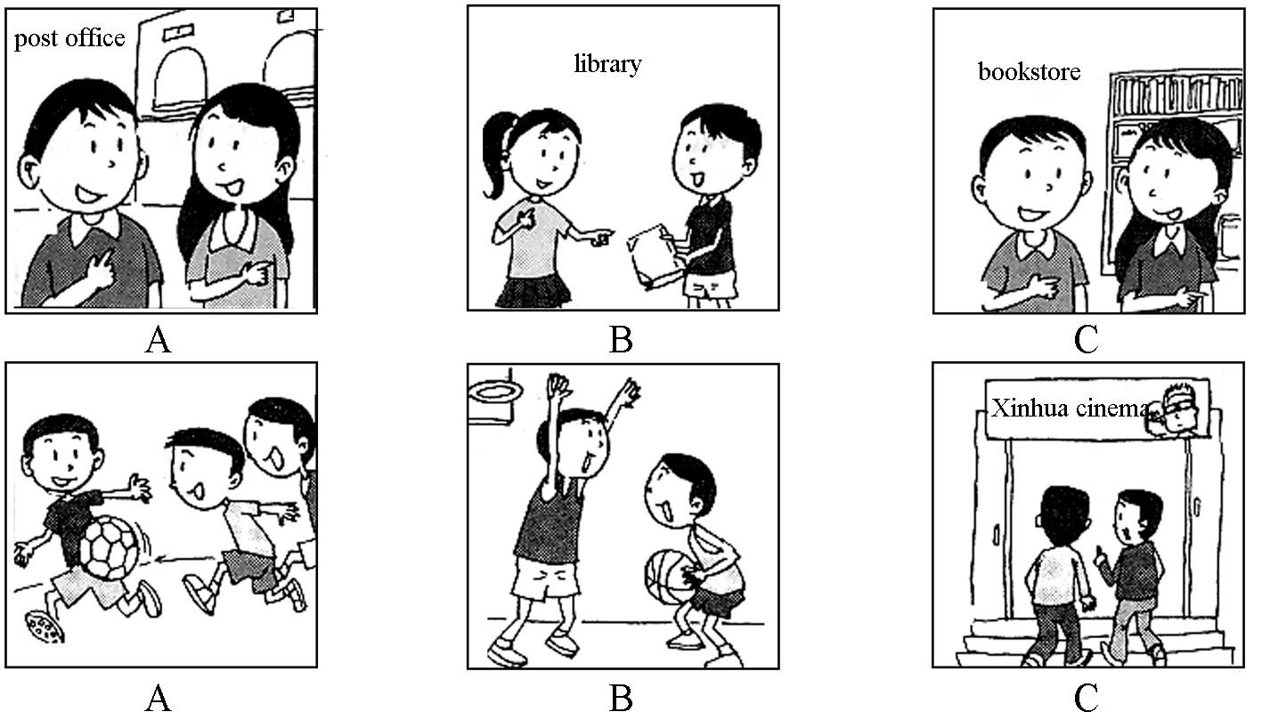
9.

10.

(三) 听五段对话和五个问题，选择正确答案。每段对话及问题读两遍。你将有15秒钟的时间阅读下面5个小题。
11. A. Warm. B. Cold. C. Hot.
12. A. Yes, he is. B. No, he isn’t. C. We don’t know.
13. A. In 2005. B. Six years ago. C. In 2000.
14. A. He likes loud music. B. The house here is too old.
C. He wants to live in a quiet place.
15. A. Fish. B. Chicken. C. Beef.
(四) 听一段长对话，选择正确答案。对话读两遍。你将有15秒钟的时间阅读下面5个小题。
16. What are the speakers mainly talking about?
A. Life. B. Camping. C. Plans.
17. What will the woman do in the city?
A. Work at a store. B. Attend a school. C. Have a picnic.
18. Who will the woman stay with?
A. The man. B. Her family. C. The man’s brother.
19. What do they do in the morning when they camp?
A. Go swimming. B. Play basketball. C. Tell stories.
20. What can we learn from the conversation?
A. The woman has worked for four summers.
B. John is the man’s brother.
C. Summer vacation is coming.
(五) 听短文，回答下面五个问题，选择正确答案。短文读两遍。你将有15秒钟的时间阅读下面5个小题。
21. When did this happen?
A. One afternoon. B. One night. C. One morning.
22. How many persons were there in the room when someone was knocking at the door?
A. One person. B. Two persons. C. Three persons.
23. What did the young man wear?
A. A white shirt. B. A pair of glasses. C. Long trousers.
24. Who was the young man?
A. He was a friend of the writer’s.
B. He was a friend of the writer’s brother’s.
C. He was a strange man to them.
25. What was probably the end of the story?
A. The young man was taken away by the police.
B. The young man became their friend.
C. The young man ran away.

第二部分 语言知识运用（共两节, 满分25分）
第一节 语法和词汇 (共15小题, 每小题1分; 满分15分)
从A、B、C、D四个选项中选出可以填入空白处的最佳选项, 并在答题卡上将该项涂黑。
26. — Sam, would you mind if I copy the document?
— .
A. Of course not, go ahead B. Yes, please
C. Of course, do as you like D. No, you’d better not
27. — Xiao Shen-yang is so popular us.
— Yeah, he is one of my favorite pop stars.
A. for B. to C. with D. on
28. — You are on the phone, Tony.
— Yes, mum, .
A. wanted; I’m coming B. called; I’m coming
C. needed; I’ll come D. asked; I’ll come
29. — It’s half an hour’s walk from here to the bus station.
— Don’t worry, I’ll you there.
A. bring B. get C. carry D. take
30. — Is your grandpa better now?
— Er, in fact, things are . Doctors are trying their best.
A. going bad B. getting ill C. going worst D. getting worse
31. — I am not sure which tie to wear for the party.
— God! I have no idea, .
A. too B. neither C. either D. also
32. Learning country’s language is a better way of knowing culture behind it.
A. the; a B. a; the C. 不填; the D. a; 不填
33. — Mind your steps, guy! Don’t you see the words “ the grass”?
— Oh, I am sorry.
A. Keep off B. Keep out C. Take off D. Take out
34. The girl was often heard happily in her room.
A. sing B. to sing C. singing D. sings
35. — Susan stays alone in the classroom and looks sad.
— to her?
A. What happens B. What has happened
C. What is happening D. What was happening
36. It is reported that people in the world are suffering from the H1N1 flu.
A. several thousands of B. ten thousands
C. thousands of D. thousands
37. — Listen! Is Professor Johnson giving a report in the hall?
— No, it be him. He has gone to Japan.
A. needn’t B. may not C. mustn’t D. can’t
38. The teacher has already told me but I’m still not clear to do next.
A. how B. what C. why D. whether
39. — Taking a walk in the evening is a good .
— So it is; it keeps us healthy.
A. habit B. hobby C. rule D. favor
40. — Can you help me with my business?
— I’d like to, I have a meeting to attend.
A. because B. as C. but D. and

第二节 完形填空 (共10小题, 每小题1分; 满分10分)
阅读下面短文,掌握其大意,然后从41—50 各题所给的四个选项（A、B、C和D）中选出最佳选项,并在答题卡上将该项涂黑。
Once there was a king who told some of his people to dig a pond (池子).The king then told his people that one person 41 each family had to bring a glass of milk during the night and put it into the pond. So, by the morning, the pond should be 42 of milk.
After 43 the order, everyone went home. As one man prepared his milk, he thought that since everyone was bringing milk, he would just 44 a glass of water and put that into the pond instead. 45 it was dark at night, no one would notice it, so he quickly went and put the water into the pond and 46 home.
In the morning, the king went to visit the pond. To his 47 , the pond was only filled with water! What happened? Yes! Everyone had the same idea 48 that man. They all thought, “I don’t have to waste my milk. Someone else will do it.”
Dear friends, when you plan to help poor people or people in trouble, do not think that 49 will take care of it. Instead, it starts with you. If you don’t do it, no one else will, so change yourself and make a 50 .
41. A. at B. from C. on D. with
42. A. filled B. empty C. crowded D. full
43. A. giving B. refusing C. receiving D. offering
44. A. hide B. steal C. waste D. drink
45. A. If B. Since C. While D. After
46. A. left B. came C. returned D. arrived
47. A. surprise B. satisfaction C. joy D. taste
48. A. with B. to C. as D. of
49. A. others B. the others C. none D. neither
50. A. face B. mistake C. living D. difference

第三部分 阅读理解（共20小题,每小题1.5分; 满分30分）
阅读下列短文,从每题所给的四个选项（A、B、C和D）中, 选出最佳选项, 并在答题卡上将该项涂黑。

A
Take a look at the following ads! You may find some useful information you need here!
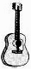 | Guitar lessons  Experienced musician from Australia. Good at teaching kids for 5 years!  For more information, please visit Larry’s website: www.music.com.au
 | Lost dog  Medium size, with brown spots and white short hair. Answer you when you call it David. Many thanks for sending it back.  Call Susan at 7328059
 | Taxi driver wanted  Full time or part time. Experience and a good knowledge of the city are necessary. English is also a must.  Under 45 years old.  Call Mr. White at 5132683.
 | Apartment for sale  Two bedrooms, a kitchen and a bathroom.  Hot water 8:00-18:00.  Beautiful sights out of the windows.  E-mail: sdgt@yahoo.cn.
51. If you want to have a guitar lesson, you may ________ .
A. call Susan at 7328059 B. surf the website:www.music.com.au
C. telephone Mr. White at 5132683 D. e-mail sdgt@yahoo.cn
52. Who is the owner of the lost dog?
A. Mr. White B. Larry C. Susan D. David
53. If you want the job as a taxi driver, you should ________.
A. master at least three languages B. know the city very well
C. be an experienced driver D. both B and C
54. Which information about the apartment is not mentioned in the table?
A. It has a beautiful view. B. It has hot water in the daytime.
C. It has three floors. D. It has a kitchen.
55. How can you contact the owner of the apartment for more information?
A. By sending an e-mail. B. By going to visit it.
C. By making a phone call. D. By sending a fax (传真).

B
Whenever the sun dropped and the blue sky came up, my father and I used to climb the mountain near my house. Walking together, my father and I used to have a lot of conversations through which I learned lessons from his experiences. He always told me, “You should have goals like climbing the mountain.” Without the mountain-climbing that we both enjoyed, we couldn’t have enough time to spend together because my father was very busy. I really got a lot from mountain-climbing. It gave me time to talk with my father and to be in deep thought as well as develop my patience (耐力).
Once we climbed a very high mountain. It was so challenging for me because I was only ten years old. During the first few hours of climbing, I enjoyed the flowers and trees, and the birds’ singing, but as time passed, I got a pain in both of my legs. I wanted to quit climbing. In fact, I hated it at that moment, but my father said to me, “You can always see a beautiful sky at the top of the mountain, but you can’t see it before you reach the top. Only there at the top, can you see all of the nice things, just like in life.”
At that time, I was too young to understand his words. But later after that, I got new hope and confidence (信心). I found myself standing at the top of the sky, which was as clear as crystal (水晶).
56. The passage tells us that mountain-climbing was ________ for Father and Son.
A. hard B. enjoyable C. painful D. comfortable
57. The word “quit” in the passage means “________”.
A. carry on B. put off C. give up D. pick up
58. Which of the following is similar in meaning to the father’s words in the second paragraph?
A. You will get all you need at the top of the mountain.
B. The sky is always as clear as crystal.
C. You can find life is full of nice things.
D. Never give up half-way.
59. We can infer (推断) from the last paragraph that ________.
A. the writer was very successful in his life
B. the writer didn’t reach the top of the mountain
C. though the writer was young, he could understand his father
D. the writer used to stop half-way when he climbed the mountain
60. The best title for the passage is“________”.
A. Reaching the Top of the Mountain B. Enjoy the Beautiful Views
C. Conversations between Father and Son D. Father and I

C
If you live in the United States, the law says you can’t have a full-time job until you are 16 years old. At 14 or 15, you can work part-time after school or on weekends, and during summer you can work 40 hours each week. Does all that mean that if you are younger than 14, you can’t earn (赚) your own money? Of course not! Kids who are between the ages of 10 and 13 can earn money by doing lots of things.
Valerie, 11, told us that she made money by cleaning up other people’s yards. Lena, 13, makes money by knitting (织) dog sweaters and selling them to her neighbors, and Reisa said she had started taking art classes and showing her work to people. People have asked her to draw pictures for them and they pay her for them. Jasmine, 13, writes articles for different magazines!
Earning is learning. By working to earn your own money, you are learning the skills you will need to succeed in life. These skills can include things like getting along with others, using technology (技术) and using your time. Some people think that asking for money is a lot easier than earning it; however, when you make your own money, you don’t have to depend on someone else. The five dollars that you earn will probably make you feel a lot better in your hand than the twenty dollars you ask for.
61. Kids can have full-time jobs at the age of in the USA.
A. 17 B. 14 C. 13 D. 10
62. If you are 15 years old, you can’t work ________.
A. after school B. on weekends C. during summer D. on weekdays
63. Reisa makes money by .
A. cleaning up other people’s yards
B. drawing pictures for others
C. writing articles for different magazines
D. knitting dog sweaters and selling them to her neighbors
64. According to the passage, which of the following is Not True?
A. You are learning how to succeed by working in your teens.
B. Kids are encouraged to live independently in the USA.
C. Earning one’s money is better than asking for money from others.
D. Kids don’t need to get along with others when making money.
65. From the passage we know that ________.
A. parents won’t let their children earn their own money
B. it’s hard for kids under 14 years old to earn money in the USA
C. kids can learn skills if they try to earn money on their own
D. if kids try to earn money, they won’t have enough time to study

D
There is not enough oil in the world now. As time goes by, it becomes less and less, so what are we going to do when it runs out? Perhaps we will go back to using horses, carriages and bicycles.
In the Second World War, some people didn’t use gas made from petroleum (石油) in their cars. They made gas from wood and plants instead. The car didn’t go fast, but they ran, so this was better than nothing. However, in the future, we can’t cut down all our trees to make gas; we need our trees for other things, too.
Besides different types of gas, we can also use electricity (电) to run our cars, but first we must make the electricity! Some countries have coal and they make electricity with that, but we might not always have coal, either. Other countries have big, strong rivers, and they can use the power of water to turn turbines (涡轮机) and make electricity more easily and cheaply.
We are also able to get power from the ocean tides. We put turbines into the mouth of the river. Then the tide comes in, the water turns the turbines and then it goes out, it turns them again.
Which of these ways will be used to run our cars in the future?
66. When might people have to go back to using horses and carriages?
A. When they are poor. B. When they run out of oil.
C. When they need more exercise. D. When there aren’t any big trees in the world.
67. What did some people use to make gas in the Second World War?
A. Water B. Coal C. Wood and plants D. Tides
68. How many ways are suggested to make electricity in the passage?
A. 2 B. 5 C. 4 D. 3
69. According to the passage, which of the following statements is True?
A. There is more petroleum than we can use now.
B. Trees are needed for some other things besides making gas.
C. We got electricity from ocean tides in the old days.
D. Gas wasn’t used to run cars in the Second World War.
70. The passage is mainly about ________ .
A. how to run our cars B. what to do when oil runs out
C. different types of gas D. the ways to make electricity

试卷类型：A
泰安市二〇〇九年高中段学校招生考试
英 语 试 题
第II卷（非选择题 共40分）
注意事项：
1. 用钢笔或圆珠笔直接答在试卷上。
2. 答卷前将密封线内的项目填写清楚。

第四部分 书面表达（共三节）
得分 | 评卷人

- 词汇运用（共两题，满分15分）
(一) 单词拼写（共5小题，每小题1分；满分5分）
根据句意和首字母或汉语提示，将单词的正确形式写在题中相应的横线上。
71. We can enjoy f air in the countryside.
72. Rush hour is the time of day when t is very heavy.
73. Listening to music is a way of (放松) yourself.
74. It’s hard to (想象) how they can improve English so quickly.
75. The astronauts (描述) what they had seen in space.
(二) 综合填空（共10小题，每小题1分；满分10分）
根据短文意思，用方框中所给词语的适当形式填空，使文章通顺、完整(其中有两个多余选项)。
at, hard, change, up, before, win, happen,
down, choose, practise, come, part
Life is not easy, so I’d like to say “When anything (76) , believe in yourself!” When I was a young boy, I was too shy to speak to anyone. My classmates often laughed (77) me. I was sad but could do nothing. Later, something happened, and it (78) my life. It was an English speech contest(比赛). My mother asked me to take (79) in it. What a terrible idea! It meant I had to speak (80) all the teachers and students of my school!
“Come on, boy. Believe in yourself! You are sure to (81) .” Then mother and I talked about many different topics. At last I (82) the topic “Believe in yourself”. I tried my best to remember all the speech and (83) it over 100 times. With my mother’s great love, I did well in the contest. I could (84)______ believe my ears when the news came that I had won the first place. I heard the cheers from the teachers and students. Those classmates who once looked (85) on me, now all said congratulations to me.
第二节 任务型阅读 (共5小题，每小题2分； 满分10分)
得分 | 评卷人
阅读下面的短文，并完成短文后的任务。
Waste can be seen everywhere in the school. Some students ask for more food than they can eat and others often forget to turn off the lights when they leave the classroom. They say they can afford these things. But I don’t agree with them.
Waste can bring a lot of problems. Although China is rich in some resources (资源), we are short of others, for example, fresh water. It is reported that we will have no coal or oil to use in 100 years. So if we go on wasting our resources, what can we use in the future and where can we move? Think about it. (88) I think we should say no to the students who waste things every day. Everybody should stop wasting as soon as possible.
In our everyday life, we can do many things to prevent (阻止) waste from happening, for example, turn off the water taps when we finish washing, turn off the lights when we leave the classroom, try not to order more food than we need, and so on. Little by little, everything will be changed. (89) Waste can be stopped one day, if we do our best.
任务1：根据要求答题。(请注意问题后的词数要求)
86. List the wastes mentioned in the first passage: (within 15 words)
_________________________________________________________________
87. What problems can waste bring? (within 20 words)
(1) ______________________________________________________________
(2) ______________________________________________________________
任务2：将短文中划线的句子翻译成汉语。
88. ______________________________________________________________
89. ______________________________________________________________
任务3：请给短文拟一个适当的标题：(within 5 words)
90. ______________________________________________________________
得分 | 评卷人
- 写 作 (共1题，满分15分)

六月六日是“全国爱眼日”。为此，某中学生英文报拟组织一次征文活动。请你结合生活实际写一篇题目为《如何保护眼睛》的征文稿，内容要点包括：
1、眼睛的重要性；
2、保护眼睛的措施：
（1）不要长时间看书报；
（2）不要在太强或者太弱的光线下看书；
（3）坚持做眼保健操；
……
注 意：词数：80～100；不要逐条翻译，可适当发挥。
How to Protect Our Eyes
_____________________________________________________________________________
泰安市二〇〇九年高中段学校招生考试
英语试题参考答案及评分标准
第Ⅰ卷（三部分 共80分）
第一部分：听力 (共25小题，每小题1分；满分25分)
1—5 BCABC 6 —10 BABBC 11—15 CABCB
16—20 CABAC 21—25 BABCA
第二部分：英语知识运用（共两节,满分25分）
第一节：语法和词汇(共15小题，每小题1分；满分15分)
26—30 ACADD 31—35 CBACB 36—40 CDBAC
第二节：完形填空 (共10小题，每小题1分；满分10分)
41—45 BDCAB 46—50 CACAD
第三部分：阅读理解（共20小题，每小题1.5分；满分30分）
51—55 BCDCA 56—60 BCDAA
61—65 ADBDC 66—70 BCDBB
第Ⅱ卷（非选择题 共40分）
第四部分：书面表达（共三节）
- ：词汇运用（共两题，满分15分）
(一)单词拼写（共5小题，每小题1分；满分5分）
71. fresh 72. traffic 73. relaxing 74. imagine 75. described
(评分要求：所填单词、词语只要符合题意，语法正确，拼写无误，都可得分；否则不得分)
(二) 综合填空（共10小题，每小题1分；满分10分）
76. happens 77. at 78. changed 79. part 80. before
81. win 82. chose 83. practised 84. hardly 85. down
（评分要求： 所填单词、词语只要符合题意，语法正确，拼写无误，都可得分；否则不得分。）
第二节：任务型阅读 (共5小题，每小题2分；满分10分)
86. ask for more food，forget to turn off the lights
(评分要求：要求列出要点，而且与参考答案的意思相近。)
87. (1) We’ll be short of resources.(fresh water, coal or oil.)
(2) We’ll have nothing to use and nowhere to move./What can we use in the future and where can we move?
(评分要求：只要学生写出任意两种即可得分。)
88. 我认为我们应该对那些天天浪费东西的学生说不。
(评分要求：要求在准确、全面的基础上，翻译成较为通顺的汉语，并表达出作者的思路，关键词语为say no to。)
89. 如果我们都尽力的话，将来有一天浪费就不会发生了。
(评分要求：要求在准确、全面的基础上，翻译成较为通顺的汉语，并表达出作者的思路，关键词为can be stopped one day。)
90. Stop wasting/No more wasting
(评分要求：根据与文章整体内容的相关程度酌情给分。)
第三节：写作 (共1题，满分15分)
（一）One possible version：
How to Protect Our Eyes
Eye is the window of our mind. We use our eyes to see everything around us. Without eyes, nothing is left beside you but darkness.
How to protect our eyes? It’s not right to keep your eyes working for a long time. You’d better not read in a strong or poor light. Don’t read in bed or on a moving bus. Remember to keep your books away from your eyes for about a foot and do eye-exercises every day. What’s more, a balanced diet is necessary.
Follow my advice and form a good habit. It’s time to say goodbye to thick glasses.

听力录音说明

总体说明：
1．录音稿中“M”表示男声，“W”表示女声。读题时注意男女声顺序。小题序号只读一遍，读作“No.”.
2．读录时要严格依照下面录音说明中的时间间隔要求。要保证两题之间给学生留出读题、做题的时间。
3．下面录音说明中斜体部分为录音要求及说明，黑体部分全部为需读录内容。

具体说明：
剪辑轻音乐作录音测试前奏
(读录前剪辑一段20~30秒的欢快的轻音乐作前奏)
音乐结束，读试题题头：
泰安市二〇〇九年高中学段招生考试英语试题
停顿3秒继续：
听力部分
停顿5秒后，开始读试题：
(一) 听句子，选择适当的应答语。每个句子读两遍。
停顿5秒后读题，每个句子读两遍，第一遍读完后停顿3秒钟再读第二遍，每两小题之间停顿5秒钟。
1. What’s the matter with you, Jack?
2. How does your daughter go to school every day?
3. I missed the football game on TV last night.
4. The shirt looks smart on you.
5. We are leaving for London now, have you taken the air plane tickets?
停顿10秒后
(二) 听对话，选择相应的图画。每段对话读两遍。
停顿5秒后读试题，每段对话读两遍，第一遍读完后停顿3秒钟再读第二遍，每小题之间停顿5秒钟。
6. W: Mike, your watch is very nice.
M: Thank you, Lucy. It’s my birthday present from my aunt.
7. M: Where do you live?
W: I like living in the countryside. I drive a car to work every day.
8. W: Will you be here at ten o’clock?
M: No, I’ll be there thirty minutes later.
9. W: Do you have books about computers?
M: Yes, we do. Here is one about the ABC of computers.
W: Thanks. How long may I keep it please?
M: Two weeks.
10. M: What are you going to do this afternoon?
W: I’ve no idea.
M: Shall we play basketball?
W: No. Let’s go to the movies.
M: OK. That’s a good idea.
停顿10秒后
(三) 听五段对话和五个问题，选择正确答案。每段对话及问题读两遍。你将有15秒钟的时间阅读下面5个小题。
停顿5秒后读对话和问题，先读对话两遍，再读问题两遍，第一遍读完后停顿3秒钟再读第二遍，每两小题之间停顿5秒钟。小题序号只读一遍，读作“No.”“Q:”读作“Question:”，只读一遍。
11. M: This heat is killing me!
W: Me too!
M: I would like a cold drink. What about you, Linda?
W: Why not? I’ll get you one.
Q: What is the weather like now?
12. W: What is that man near the door? Is he a doctor?
M: No, he is a policeman.
Q: Is that man a policeman?
13. M: The Smiths have gone back to New York.
W: Really? How long have they lived there?
M: For six years.
Q: When did Mr. Smith move there?
14. W: I hear you are going to move to a new house, aren’t you?
M: Yes, it’ll be a bit expensive, but the man upstairs always plays music loudly.
Q: Why is the man going to move to a new house?
15. M: How about food? Which do you like best—beef, fish, or chicken?
W: Well, I like them all, but I’d say I like chicken the best. It’s healthy…and I know a lot of different ways to cook chicken.
Q: What is the woman’s favorite?
停顿10秒后
(四) 听一段长对话，选择正确答案。对话读两遍。你将有15秒钟的时间阅读下面5个小题。
停顿15秒后读对话
M: What are you going to do after you return from Washington?
W: I’m going to stay in the city.
M: What will you do all day?
W: I’m going to work with my father at the store. In the evening, I’ll read books. On the weekends, I’ll go to beach with my family.
M: Have you ever worked?
W: No, but I can learn. What are you going to do this summer?
M: I’m going to camp. I’ve gone to camp for four summers.
W: I’ve never done that. What do you do there?
M: We do many things. In the morning, we go swimming. In the afternoon, we play basketball or tennis. We sit around a fire at night. We sing or tell stories.
W: That sounds wonderful.
M: It is wonderful. What’s John going to do this summer?
W: I think he’s going to the mountains with his parents.
M: Well, so long, Mary. Have fun.
W: You too, Peter. Give my regards to John. I’ll see you in September.
停顿5秒
Now listen again.
停顿5秒
M: What are you going to do after you return from Washington?
W: I’m going to stay in the city.
M: What will you do all day?
W: I’m going to work with my father at the store. In the evening, I’ll read books. On the weekends, I’ll go to beach with my family.
M: Have you ever worked?
W: No, but I can learn. What are you going to do this summer?
M: I’m going to camp. I’ve gone to camp for four summers.
W: I’ve never done that. What do you do there?
M: We do many things. In the morning, we go swimming. In the afternoon, we play basketball or tennis. We sit around a fire at night. We sing or tell stories.
W: That sounds wonderful.
M: It is wonderful. What’s John going to do this summer?
W: I think he’s going to the mountains with his parents.
M: Well, so long, Mary. Have fun.
W: You too, Peter. Give my regards to John. I’ll see you in September.
停顿15秒后读第下一题，给学生留出做题时间。
(五) 听短文，回答下面五个问题，选择正确答案。短文读两遍。你将有15秒钟的时间阅读下面5个小题。
停顿15秒
It was quite late at night. I was reading a newspaper alone in my room when I heard someone knocking at the door. I opened it and saw a young man with glasses standing there. He said that he was a friend of my brother’s and wanted to have a talk with him. I didn’t know if my brother had such a friend, but I had to let him in.
As we talked, I found that he knew nothing about my brother. Then I came to know that his words were not true. Suddenly my brother rushed in and the young man was so surprised that he didn’t know what to do for a moment. We caught the man and called the police at the same time.
停顿5秒
Now listen again.
停顿5秒
It was quite late at night. I was reading a newspaper alone in my room when I heard someone knocking at the door. I opened it and saw a young man with glasses standing there. He said that he was a friend of my brother’s and wanted to have a talk with him. I didn’t know if my brother had such a friend, but I had to let him in.
As we talked, I found that he knew nothing about my brother. Then I came to know that his words were not true. Suddenly my brother rushed in and the young man was so surprised that he didn’t know what to do for a moment. We caught the man and called the police at the same time.
停顿10秒
听力部分到此结束。

声明：本资料由 考试吧（Exam8.com） 收集整理，转载请注明出自 http://www.exam8.com
服务：面向较高学历人群，提供计算机类，外语类，学历类，资格类，会计类，工程类，医学类等七大类考试的全套考试信息服务及考前培训.

